Modeling, Forecasting and Diagnostics of AAPL and XLK
From ARIMA to neural networks, through cointegration, conditional volatility and generative AI
TEK-UP, Time Series course (Data Science & AI), 2026. Authors: Ines Belkahla, Sarra Ben Bettaieb, Ouissem Oueslati. Theme: finance.

Abstract
We study daily adjusted prices of Apple (AAPL) and the technology-sector ETF XLK from January 2019 to September 2026. Using a strict chronological split (1,750 training and 195 test returns), we fit ARIMA/SARIMA, a VAR, cointegration tests, GARCH models, and LSTM and GRU networks, and compare them on 186 rolling forecast origins with Diebold-Mariano tests. Log prices are I(1) and returns are stationary but heavy-tailed. Returns show almost no usable predictability, but volatility clusters strongly and a GARCH(1,1) model with Student-t errors passes all residual diagnostics. No model, including the networks, significantly beats a random walk with drift. We therefore recommend the random walk for point forecasts and GARCH for uncertainty.

1. Introduction
Choice of theme. We chose finance because daily prices of a liquid stock and its sector ETF are freely available, long, and show exactly the features studied in the course: unit roots, volatility clustering, and a correlated pair suited to VAR and cointegration analysis. AAPL and XLK are strongly related (return correlation 0.83), although AAPL is itself a constituent of XLK, which we keep in mind when interpreting the results.
Question. Can classical econometric models or recurrent neural networks forecast AAPL better than a random walk with drift, and can we quantify the forecast uncertainty reliably? Every modeling choice below is justified by a statistical diagnostic. Sections 2 to 6 follow the analysis in order, Section 7 covers the use of generative AI, and Section 8 discusses limitations.

2. Data and preparation
Source. Yahoo Finance, retrieved with quantmod (R) and yfinance (Python). We use the adjusted close, which Yahoo adjusts for splits and dividends; no other transformation was applied. Period: 2019-01-03 to 2026-09-29 (1,945 daily returns).
Derived variables. Log price, log return, 20-day moving average and 20-day realised volatility (annualised). Trading days form an irregular calendar; we kept the true trading-day index and did not fill holidays, which would create artificial zero returns.
Split. Chronological 90/10: training 2019-01-03 to 2025-12-17 (1,750 returns), test 2025-12-18 to 2026-09-29 (195). All exploration, identification and hyperparameter selection use the training set only. Seeds are fixed (42) and downloaded data are cached for exact reproducibility.
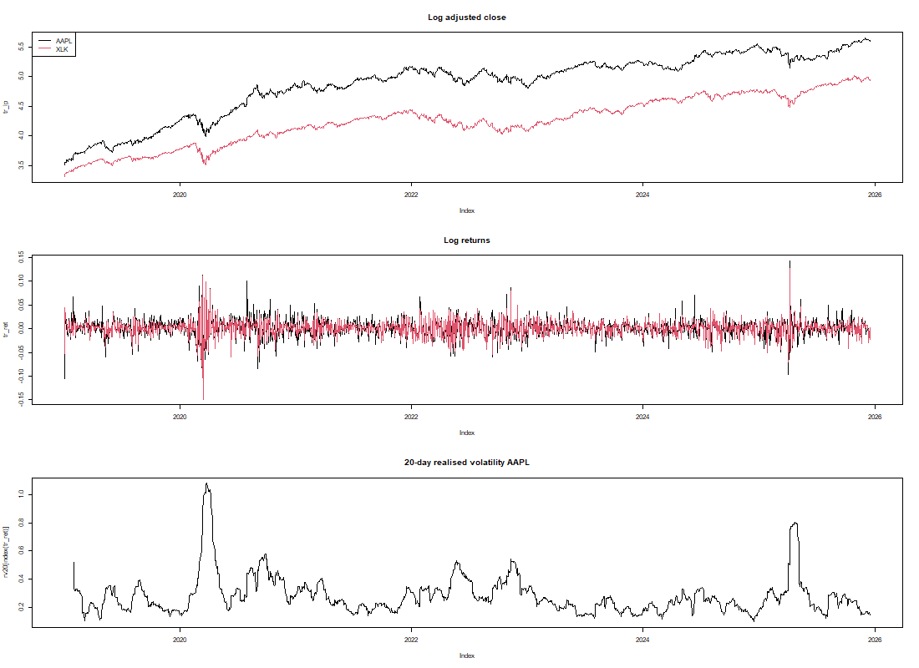 Figure 1. Adjusted close (base 100), log returns and 20-day realised volatility, training period.

3. Exploratory analysis
Descriptive statistics. Table 1 shows daily log returns on the training set. Both series are far from normal, mainly through heavy tails (excess kurtosis 6.6 and 8.9) rather than skewness.
Series | Mean | Variance | Skewness | Excess kurtosis | Jarque-Bera p
AAPL | 0.001131 | 0.000384 | -0.083 | 6.59 | < 0.001
XLK | 0.000895 | 0.000284 | -0.289 | 8.89 | < 0.001
Table 1. Descriptive statistics of daily log returns (training set).
ACF and PACF (Figure 2). The ACF of the log price decays very slowly (about 0.88 at lag 40) and its PACF has a single spike at lag 1, the signature of a unit root. For returns, the largest autocorrelations are about -0.085 at lag 1 and about -0.09 and +0.10 at lags 8 and 9, against a 95% band of about 0.047. The Ljung-Box test rejects white noise (p < 0.001), but these correlations explain about 1% of the variance, the signs alternate with no economic story, and the band assumes constant variance, so some spikes are probably spurious. There is no sharp cutoff in either function, so the plots do not point to a clean AR or MA order.
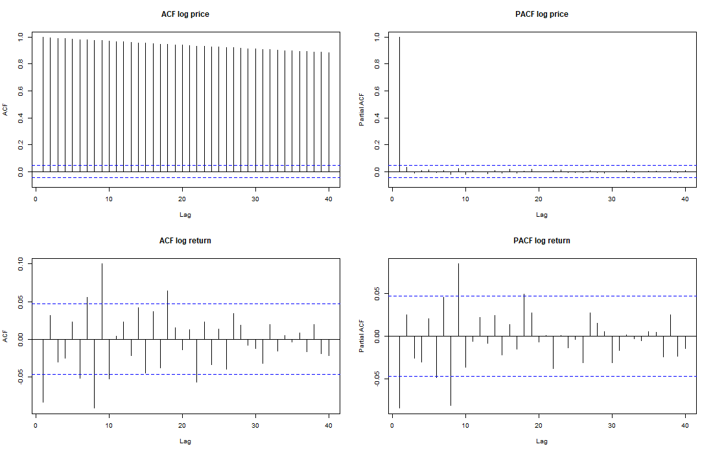 Figure 2. ACF and PACF of log price (top) and log return (bottom).
Decomposition (Figure 3). The STL trend rises from about 3.6 to 5.5 in log price. The seasonal component is an artefact: with a periodic seasonal window STL forces the same yearly shape to repeat, so it reflects individual events (2020, 2022) and not seasonality. The remainder shows long swings of up to +/-0.3 that a smooth trend cannot follow, as expected for a stochastic trend. We conclude there is no genuine seasonality.
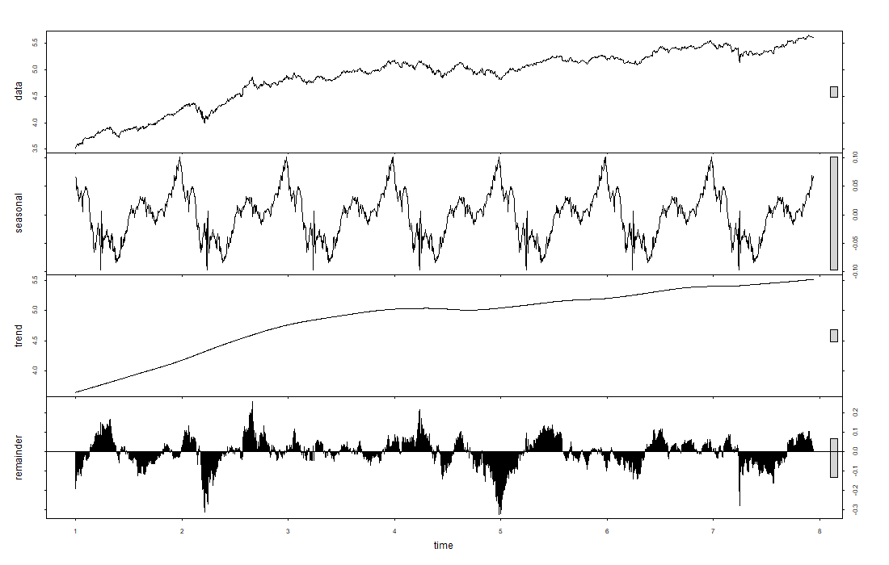 Figure 3. Robust STL decomposition of the AAPL log price.
Outliers. 19 of 1,750 returns lie beyond 3 interquartile ranges, clustered in March 2020 (COVID-19 crash), April 2025 and a few earnings or macro days; the largest absolute moves are on 2025-04-09 (14.3%) and 2020-03-16 (13.8%). [TO FILL: confirm the cause of the April 2025 moves from a news source.] We keep them: they are genuine events, and removing them would erase the volatility that GARCH must model.
Stationarity. ADF (H0: unit root) and KPSS (H0: stationary) have opposite nulls and agree in every case (Table 2). Log prices are non-stationary, returns are stationary, so one difference is required: d = 1.
Series | ADF p | KPSS p | Conclusion
AAPL log price | 0.29 | < 0.01 | non-stationary
AAPL log return | < 0.01 | > 0.10 | stationary
XLK log price | 0.22 | < 0.01 | non-stationary
XLK log return | < 0.01 | > 0.10 | stationary
Table 2. Stationarity tests (the software caps reported p-values at 0.01 and 0.10).

4. Classical modeling

4.1 ARIMA and SARIMA
Identification. Because the ACF/PACF were inconclusive, we compared a BIC grid (p, q up to 3, d = 1, with drift) with an automatic search (auto.arima, pmdarima). Both select ARIMA(1,1,0) with drift (BIC -8809.98); ARIMA(0,1,1) is within 0.5 BIC points, and the pure random walk with drift is 3.4 points behind (Table 3). A seasonal search with period 5 returns the same non-seasonal model, so SARIMA is not justified.
Model | BIC
ARIMA(1,1,0) | -8809.98
ARIMA(0,1,1) | -8809.44
ARIMA(0,1,0) | -8806.56
ARIMA(1,1,1) | -8803.83
ARIMA(2,1,0) | -8803.64
Table 3. Five best models by BIC.
Residual diagnostics (Figure 4). Ljung-Box rejects independence (p = 5.0e-6 at lag 10, 2.6e-6 at lag 20), Jarque-Bera and Shapiro-Wilk reject normality (heavy tails), and the ARCH-LM test strongly rejects constant variance (p < 0.001). The model therefore leaves some structure in the mean and, above all, ignores the changing variance. Since Ljung-Box assumes constant variance, part of its rejection is a variance artefact; we return to this in Section 4.3. We did not add AR terms at lags 8 and 9, which would likely overfit.
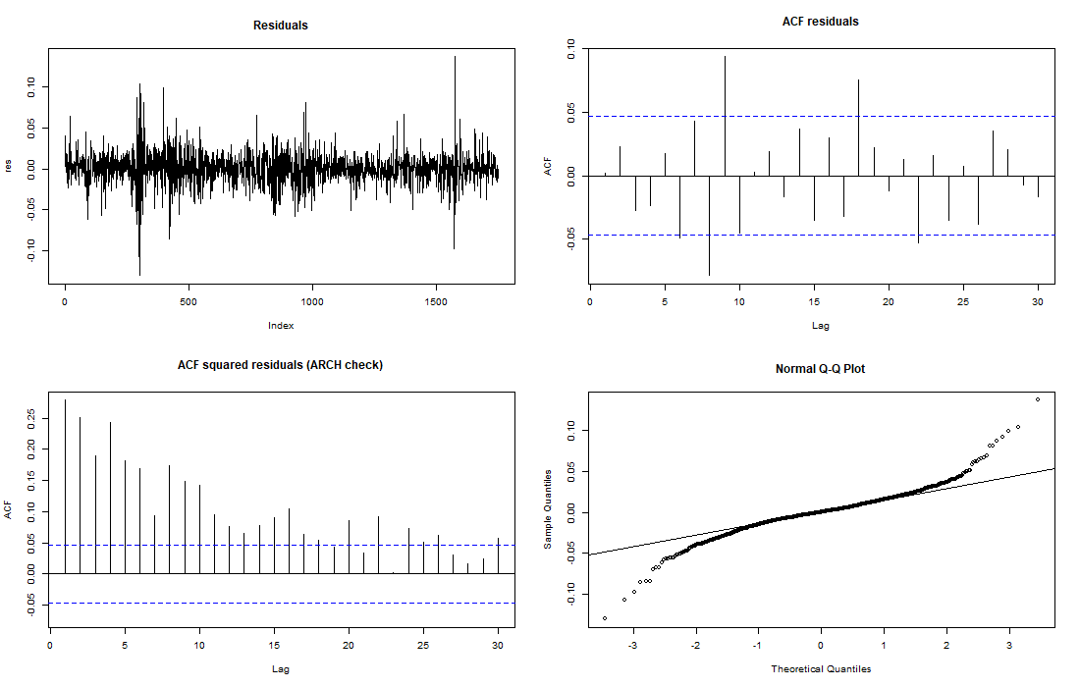 Figure 4. Residual diagnostics of ARIMA(1,1,0).

4.2 VAR, Granger causality and cointegration
Cointegration. Both log prices are I(1) (Section 3). The Phillips-Ouliaris test gives p >= 0.15 and the Engle-Granger test p = 0.54 (Python). The Johansen trace test does not reject r = 0 (18.94 against a 5% critical value of 19.96; r <= 1: 2.16 against 9.24). We repeated it for 3 deterministic terms and 4 lag lengths (12 specifications in R): the statistic never exceeds its 5% critical value (Table 4). In Python, four specifications with no constant at all reject, but a model without a constant is inappropriate for log prices around 3.5 to 5.6, so we disregard them. There is no evidence of a stable long-run link, and a VECM is not justified.
Deterministic term | Trace statistic range (K = 2 to 10) | 5% critical value
none (unrestricted constant) | 9.1 to 11.0 | 17.95
constant in relation | 16.1 to 18.9 | 19.96
trend | 17.6 to 20.8 | 25.32
Table 4. Johansen robustness (R).
VAR on returns. BIC selects one lag (AIC selects nine). Granger tests: the past of XLK helps predict AAPL (p = 0.0075, coefficient -0.13, a mean-reversion effect), but AAPL does not help predict XLK (p = 0.49). Granger causality is predictive, not structural, and the p-values assume constant variance, so we treat them as suggestive. Same-day returns are strongly related (instantaneous p < 0.001), which is comovement, not lead-lag. Residual tests reject: portmanteau p = 4.5e-9, multivariate Jarque-Bera p < 0.001 (kurtosis-driven), multivariate ARCH p < 0.001. The Python implementation reproduces these results to four decimals.
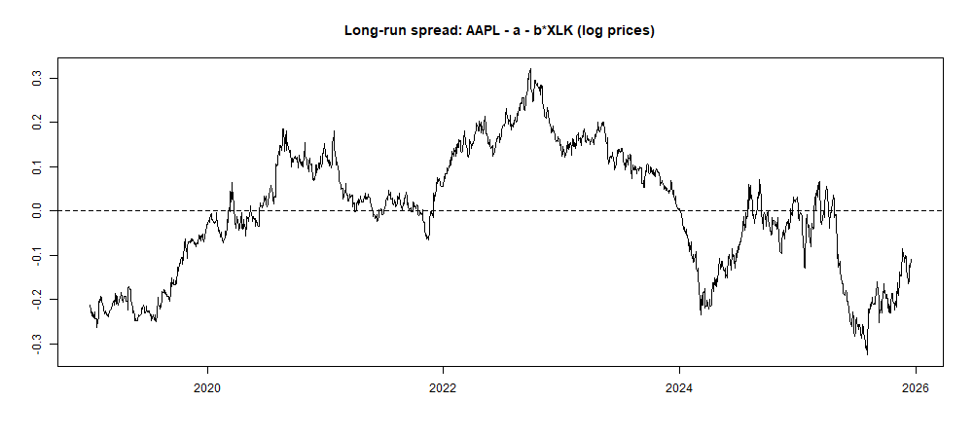 Figure 5. Long-run spread of the AAPL on XLK regression (log prices); it wanders instead of reverting.

4.3 Conditional volatility: ARCH and GARCH
ARCH effects. The ARCH-LM test on the ARMA(1,0) residuals gives p < 0.001 at 5, 10 and 20 lags. We fitted GARCH(1,1) and variants on returns in percent (Table 5).
Model | Log-likelihood | BIC (per obs.)
GARCH(1,1), normal | -3467.4 | 3.9841
GARCH(1,1), Student-t | -3393.1 | 3.9034
GARCH(1,1), skewed t | -3392.7 | 3.9072
GARCH(2,1), t | -3392.2 | 3.9066
GARCH(1,2), t | -3391.8 | 3.9062
GJR-GARCH(1,1), t | -3383.9 | 3.8972
Table 5. GARCH variants (all with an AR(1) mean).
Choice. Student-t errors improve the log-likelihood by 74 over normal errors, as expected from the kurtosis (estimated shape 4.8). Higher orders and the skewed t add nothing. The required GARCH(1,1)-t has alpha = 0.097, beta = 0.870 and persistence 0.9675, so a volatility shock has a half-life of 21 days, and the long-run volatility is 31.6% annualised. The AR(1) term is negligible (0.002, p = 0.93).
Diagnostics of standardized residuals (Figure 6). After GARCH the ARCH-LM test no longer rejects (p = 0.35 and 0.50); Ljung-Box on the residuals gives p = 0.62 and 0.70 and on the squared residuals p = 0.47 and 0.42. The earlier ARIMA autocorrelation failure has therefore largely disappeared, which shows it was mostly a variance artefact. Jarque-Bera still rejects, as expected for t-distributed errors; the QQ-plot against the fitted t is close to the diagonal, with two extreme left-tail points slightly beyond it.
Asymmetry. GJR-GARCH has the best BIC; its leverage coefficient is significant (gamma = 0.129, p = 0.0004 in Python) and the likelihood-ratio statistic is about 18 (R). The sign-bias test on GARCH(1,1) does not detect asymmetry (p = 0.30). Because the evidence is mixed, we present GJR as a refinement and GARCH(1,1) as the baseline required by the brief.
Conditional volatility (Figure 7). The estimated volatility peaks at 112.8% on 2020-03-17, the day after the largest COVID-19 return (the model reacts to the previous day's shock), with another peak of about 90% in April 2025 and a smaller one in 2022 [TO FILL: relate to the events after checking the news].
Limitations. The Nyblom test rejects parameter stability (joint statistic 3.42 against a 1% critical value of 2.12), so parameters probably changed during the sample. The first observation is a -10.5% day; dropping it, or using a constant mean, changes the parameters by less than 0.01 (Python sensitivity check), so conclusions do not depend on either choice.
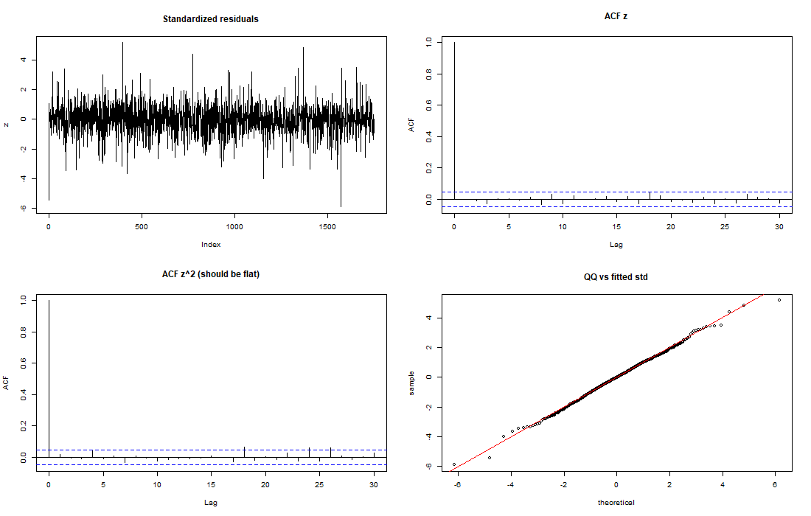 Figure 6. Diagnostics of the standardized GARCH(1,1)-t residuals.
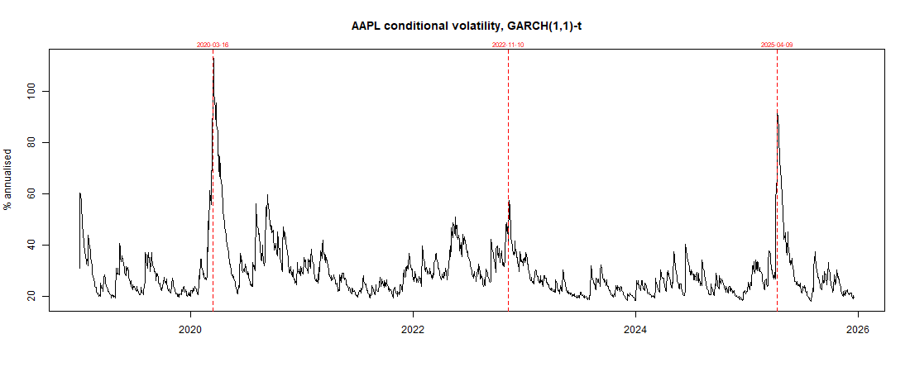 Figure 7. Conditional volatility (annualised). Dashed lines: extreme-return dates.

5. Neural networks: LSTM and GRU (Python)
Design. Both networks predict the next 10 daily returns (stationary; a network cannot extrapolate prices beyond the range seen in training), from windows of AAPL return, XLK return and 10-day volatility standardized with training statistics. Price forecasts are rebuilt by cumulating predicted returns. We used one recurrent layer (only about 1,700 training windows), dropout 0.2, Adam, early stopping on a time-ordered validation block with a 10-day gap, and fixed seeds. Windows of 20 days (about a month) and 60 days (a quarter, informed by the GARCH half-life of 21 days) and 16 or 32 units were compared.
Temporal cross-validation. Four expanding-window folds inside the training period (never k-fold). The score is the error relative to the benchmark "always predict the average training return" (ratio below 1 means better).
Architecture | Window | Units | Ratio (SD across folds)
GRU | 20 | 16 | 1.0101 (0.0071)
GRU | 20 | 32 | 1.0116 (0.0090)
GRU | 60 | 16 | 1.0054 (0.0041)
GRU | 60 | 32 | 1.0089 (0.0067)
LSTM | 20 | 16 | 1.0108 (0.0079)
LSTM | 20 | 32 | 1.0091 (0.0075)
LSTM | 60 | 16 | 1.0084 (0.0037)
LSTM | 60 | 32 | 1.0079 (0.0053)
Table 6. Walk-forward validation of the 8 configurations.
Every configuration is slightly worse than the benchmark, and the differences between configurations (about 0.2%) are noise. The selected models (LSTM 60/32 with 4,938 parameters; GRU 60/16 with 1,178) stopped after 10 and 18 epochs, showing that overfitting begins almost immediately (Figure 8). On the test set the correlation between predicted and actual 1-day returns is 0.02 (LSTM) and 0.05 (GRU), far below the roughly 0.14 needed for significance at n = 186, and the direction hit rate is 54.3% and 54.8% against 53.2% up days in the test period. The networks show no real skill.
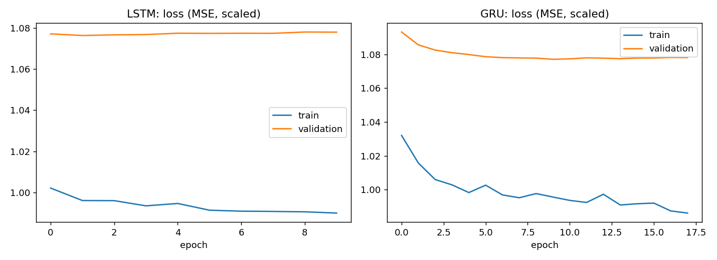 Figure 8. Training and validation loss of the selected LSTM and GRU.

6. Forecast evaluation
Protocol. We forecast from 186 rolling origins covering the whole test period at horizons h = 1, 5 and 10. ARIMA(1,1,0), VAR(1) and GARCH(1,1)-t (order fixed from the training analysis) are re-estimated at every origin; the networks are trained once. Benchmarks are the random walk with and without drift (drift from the training period). Metrics are computed on the price scale; the full MSE, RMSE, MAE and MAPE table is in Appendix B.
Model | RMSE h=1 | RMSE h=5 | RMSE h=10 | MAPE h=10 (%) | Parameters | Interpretability
Random walk | 4.863 | 11.182 | 15.216 | 4.363 | 0 | total
RW + drift | 4.854 | 11.060 | 14.858 | 4.288 | 1 | total
ARIMA(1,1,0) | 4.887 | 11.056 | 14.920 | 4.315 | 3 | high
VAR(1) | 4.865 | 11.149 | 14.933 | 4.306 | 6 | high
GARCH(1,1)-t | 4.857 | 11.088 | 14.946 | 4.303 | 5 | high
LSTM | 4.862 | 11.082 | 14.985 | 4.340 | 4,938 | low (black box)
GRU | 4.851 | 10.949 | 14.889 | 4.297 | 1,178 | low (black box)
Table 7. Forecast accuracy (price scale, 186 origins) and complexity.
All models lie within 0.7% of each other at h = 1 and within 2.4% at h = 10. Diebold-Mariano tests (squared log-price errors, Harvey correction for overlapping horizons) against the random-walk-with-drift benchmark are in Table 8: no model is significantly better. The only unadjusted p-values below 0.05 (VAR at h = 5; ARIMA and VAR at h = 10) belong to models with higher error than the benchmark, and none survives the Holm correction for 18 tests (smallest adjusted p = 0.15). The apparent 2.0%, 2.3% and 4.9% lower MSE of the drift over the plain random walk (h = 1, 5, 10) is also not significant (p >= 0.62). With 186 overlapping forecasts the test has limited power, so "no significant difference" does not prove equality.
Model | h=1: MSE ratio (p) | h=5: MSE ratio (p) | h=10: MSE ratio (p)
ARIMA | 1.011 (0.36) | 1.000 (0.96) | 1.008 (0.048)
VAR | 1.007 (0.73) | 1.015 (0.008) | 1.011 (0.042)
GARCH | 1.001 (0.72) | 1.005 (0.75) | 1.012 (0.74)
LSTM | 1.002 (0.85) | 1.004 (0.78) | 1.018 (0.56)
GRU | 0.998 (0.84) | 0.983 (0.20) | 1.002 (0.84)
Random walk | 1.004 (0.67) | 1.024 (0.62) | 1.051 (0.64)
Table 8. Diebold-Mariano tests against RW + drift (ratio below 1 favours the model; raw p-values, none below 0.05 survives Holm correction).
Interval calibration. Empirical coverage of the nominal 95% intervals is 0.968, 0.952 and 0.973 for ARIMA and 0.952, 0.941 and 0.973 for GARCH at h = 1, 5 and 10, all within about 1.5 standard errors of 95%. GARCH intervals are about 9% narrower at h = 1 (19.6 against 21.5 price units), converging by h = 10 as volatility reverts to its long-run level.
Conclusion on the best model. For point forecasts we recommend the random walk with drift: it is the simplest, costs nothing, and nothing significantly beats it. For uncertainty we recommend GARCH(1,1)-t: calibrated, slightly tighter intervals, interpretable, and it also yields volatility estimates useful for risk (computing time for 186 refits: ARIMA 7 s, VAR 2 s, GARCH 90 s). LSTM and GRU add cost and opacity without measurable benefit.
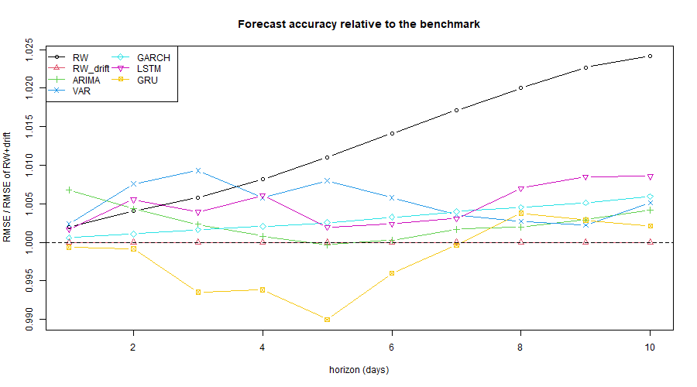 Figure 9. RMSE relative to the RW + drift benchmark, by horizon.

7. Generative AI and LLMs
This section must be completed from your own work with the LLM kit; nothing below is invented on your behalf.
7.1 Method. [TO FILL: LLM name, version and date; the three prompts (A: hypotheses from descriptive statistics; B: plain-language explanation; C: recommendations and limits) were run in a fresh session; full text in Appendix A.]
7.2 Own interpretation versus the LLM (table, 10 rows). [TO FILL: paste the comparison table from the kit: topic, our reading written before consulting the LLM, the LLM's reading, converge or diverge, evidence from our output, error type.]
7.3 Errors and approximations found in the LLM output. [TO FILL: at least 5 items, each with the quoted sentence, the verdict (correct, oversimplified, unsupported, wrong), the evidence from our results and how we corrected it. Check in particular: invented numbers, swapped ADF/KPSS hypotheses, Granger described as causation, significance inflation, cointegration claimed, predictability overstated, certainty in recommendations.]
7.4 Recommendations and their limits. [TO FILL: summary of the LLM's simulated recommendations, the limitations it listed itself, and at least four additional limitations of our own that it did not raise.]
7.5 What the LLM helped with and what it failed at. [TO FILL: one concrete example of each: gain in time or clarity, and a failure.]
7.6 Disclosure. [TO FILL, adapt if needed: An LLM was also used during the project as a coding and analysis assistant; every result was checked against the program output, and Section 7 compares our own interpretation, written before the comparison session, with a separate fresh LLM session that received only the descriptive statistics and results.]

8. Critical discussion
Model limitations. (i) Residuals of the mean models are non-normal and heteroskedastic, so classical p-values (Granger, VAR coefficients) are only suggestive; only GARCH residuals pass. (ii) GARCH parameters are not stable over the sample (Nyblom test). (iii) The test period is 195 days, a single mostly rising period (53% up days), so the drift advantage cannot be generalised and the Diebold-Mariano tests have low power. (iv) Classical models are re-estimated at every origin while the networks are trained once, which favours the former. (v) One stock and its own sector ETF: AAPL is a constituent of XLK, so some co-movement is mechanical and a cointegration result would have been partly mechanical. (vi) Many tests were run, and some raw p-values below 0.05 are expected by chance (hence the Holm correction). (vii) MAPE on price levels looks very small simply because prices change little over 10 days; skill must be judged against the random walk. (viii) Networks give no prediction intervals.
Generative AI for time-series analysis in finance. [TO FILL in your own words, 150 to 250 words: advantages (speed, explaining to non-experts, structuring hypotheses) and drawbacks (hallucinated statistics, no access to your data, tendency to agree, false confidence in investment advice, non-reproducibility of answers, data confidentiality), with examples from Section 7.]

9. Conclusion
Log prices of AAPL and XLK are integrated of order one and show no cointegration. Returns are heavy-tailed and nearly unpredictable in direction, but their volatility is predictable: a GARCH(1,1) model with t errors removes all remaining ARCH effects, with high persistence (0.97) and a volatility-shock half-life of about three weeks. ARIMA, VAR, GARCH, LSTM and GRU do not significantly outperform a random walk with drift on 186 rolling forecasts. The practical value of the analysis lies in calibrated uncertainty ranges and volatility estimates, not in price prediction, and any claim of predictability should be proven out of sample against a random walk first.

References
- Hyndman, R. J. and Athanasopoulos, G. Forecasting: Principles and Practice (3rd ed.), OTexts.
- Engle, R. F. (1982), Autoregressive conditional heteroscedasticity, Econometrica 50.
- Bollerslev, T. (1986), Generalized autoregressive conditional heteroskedasticity, Journal of Econometrics 31.
- Johansen, S. (1988), Statistical analysis of cointegration vectors, Journal of Economic Dynamics and Control 12.
- Diebold, F. X. and Mariano, R. S. (1995), Comparing predictive accuracy, Journal of Business & Economic Statistics 13.
- Hochreiter, S. and Schmidhuber, J. (1997), Long short-term memory, Neural Computation 9.
- Cho, K. et al. (2014), Learning phrase representations using RNN encoder-decoder, EMNLP.

Appendix A. Prompts and full LLM responses
[TO FILL: for each of Prompts A, B and C, paste the full prompt and the full unedited response, with the LLM name, version and date. Prompt B and its response (the explanation for a non-statistician decision-maker) is the appendix required by the brief. Add, after Prompt C, the team's own additional limitations.]

Appendix B. Full forecast accuracy table (186 rolling origins, price scale)
h | Model | MSE | RMSE | MAE | MAPE (%)
1 | GRU | 23.5296 | 4.8507 | 3.4145 | 1.1898
1 | RW + drift | 23.5593 | 4.8538 | 3.4330 | 1.1963
1 | GARCH | 23.5879 | 4.8567 | 3.4338 | 1.1971
1 | LSTM | 23.6394 | 4.8620 | 3.4305 | 1.1944
1 | Random walk | 23.6523 | 4.8634 | 3.4509 | 1.2014
1 | VAR | 23.6713 | 4.8653 | 3.4893 | 1.2157
1 | ARIMA | 23.8807 | 4.8868 | 3.4496 | 1.2018
5 | GRU | 119.8842 | 10.9492 | 8.5842 | 2.9831
5 | ARIMA | 122.2451 | 11.0564 | 8.6201 | 2.9966
5 | RW + drift | 122.3253 | 11.0601 | 8.6400 | 3.0022
5 | LSTM | 122.8049 | 11.0817 | 8.6794 | 3.0120
5 | GARCH | 122.9511 | 11.0883 | 8.6176 | 3.0004
5 | VAR | 124.2900 | 11.1485 | 8.7009 | 3.0229
5 | Random walk | 125.0353 | 11.1819 | 8.8317 | 3.0520
10 | RW + drift | 220.7458 | 14.8575 | 12.3891 | 4.2882
10 | GRU | 221.6929 | 14.8894 | 12.4380 | 4.2972
10 | ARIMA | 222.5941 | 14.9196 | 12.4639 | 4.3149
10 | VAR | 223.0045 | 14.9333 | 12.4351 | 4.3063
10 | GARCH | 223.3772 | 14.9458 | 12.3810 | 4.3033
10 | LSTM | 224.5440 | 14.9848 | 12.5702 | 4.3403
10 | Random walk | 231.5370 | 15.2163 | 12.7491 | 4.3633

Appendix C. Reproducibility
Code. Repository layout: R/01_data_eda.R to R/04_garch.R and R/06_evaluation.R (R, lead language); python/01 to python/04 (the classical core in Python) and python/05_lstm_gru.py (advanced core, Python only); notebooks/main_study.Rmd and notebooks/advanced_models.ipynb reproduce the study end to end; data/ holds the cached prices and all saved forecasts; figures/ holds every figure. All scripts use relative paths and a fixed seed (42).
Order. R/01 to R/04, then python/05_lstm_gru.py (about 7 minutes on a laptop CPU), then R/06_evaluation.R. The Python scripts 01 to 04 are independent of the R ones and reproduce the same conclusions (the VAR results are identical to four decimals).
Versions. Python: tensorflow 2.21.0, numpy 2.4.6, pandas 3.0.6, statsmodels 0.15.0, arch 8.0.0 (full list printed by the notebook). R: version 4.5.x with the packages quantmod, xts, zoo, tseries, forecast, urca, vars, moments, rugarch (sessionInfo() is printed at the end of the R notebook). [TO FILL: add the repository link.]

Appendix D. Team interpretation written before consulting the LLM
[TO FILL: paste the eight answers written in Step 1 of the LLM kit, and the time they were written.]

